**Request Advance and Deduction Flow (06/07/23)**

1. Employees can “Request Advance Pay or Loan” via app.  
   Employer can also manually request on Employees behalf from the “Work” Profile and also from the Web Admin.
2. After Request is made, it will be submitted to the HR/Finance for approval.  
   “Edit, Approve and “Decline” must be available in both the App and the Web portal.  
     
   In the Employer Backend, change the new sub-menu “Advance” to “Advance/Loan”.   
   This will have:
   1. “Create” – choose employee and create Advance/Loan manually
   2. “Approve/Decline” – list all pending requested advance to be Approved or Declined and Edit.
   3. “List” – list history of all approved and declined advance/loan. Filter by Advance and Loan, employee, last month, last year, this year and custom (as per normal filters).
3. After the “Advance/Loan” request is approved by the HR/Finance/Employer, then:  
   - For **Loans**, appropriate separate CSV files will be created (as per Bank etc) and on same date, the amount must be registered to all the Deduction tab fields automatically in the Web Admin.  
   - For **Advance Pay**, appropriate CSV files (as per bank etc) will be created after midnight of the last cut-off day, **combining** all employees that have submitted a request. Not individual CSV files. When the CSV file is made for Advance Pay/Loan, the ‘Paid Date’ field should be filled automatically in the Deduction Tab with same date.  
   - When the “Advance Pay / Loan” is approved/ rejected then the employee must get a notification and email (with Amount if approved, no amount if declined). (Currently the App does not have any section with details regarding Advance Pay/ Loan both in the Employee Profile as well as in the Work Profile).  
     
   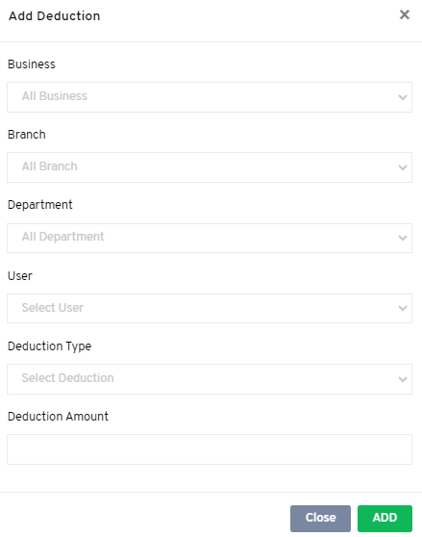

If Start Date and End Date entered in the App by Employee is the SAME date, then there will be no recurring deduction and FULL deduction will be made on that pay day.

Deduction per pay period

Paid Date

Total Amount to Deduct

Amount paid manually

Payment Date

Start Date

End Date



1. **APP Section:**In the app, request is to be for “Advance Pay” or “Loan” with pop up / drop down option:

**When Requesting Loan:**Please add these fields: “Deduction amount per pay period”, “Start Date” and “End Date”.  
All data from this request must be captured in the backend as per above section when approved HR/Finance. (Once approved, the data will automatically get transferred to all fields above).  
  
**Advance Pay:**Only 1 field will be showing, “Reason”.

* Note again: “Edit, Approve and “Decline” must be available in both the App and the Web portal.

1. Deduction report > add search field:
   1. Deduction type (all and choose)
   2. All and Choose Employee.
   3. Add ‘Deduction Type’ and ‘Paid Date’ columns

On clicking View (eye button) on each employee:  
- Report to have these columns:

1. Paid Date (payment made)
2. Manual
3. Recurring
4. Change “Amount” to “Total Amount”
5. Balance

1. **“Advance Pay” Settings/Flow:**

* Cut off day for the Advance Pay request (Until when employee must make the request)

Cut off days for advance pay to be calculated as follows for each Pay Type:  
  
**Weekly Pay**: **Within 4 days** after last Payroll processing day.(Eg. Payroll day is Friday, then request can be made either on Sat, Sun, Mon or Tue until the dedicated or rostered end of shift time).  
**Fortnightly and Bi-monthly Pay**: **Within 8 days** after last Payroll processing day…… (as above).

**Monthly Pay**: **Within 16** days after last Payroll processing day…… (as above).

Please note - this is not counting only workings days but counting ALL days (Sat/Sun/Holiday etc)  
Please note – Employee can only make ONE request for Advance Pay in any pay period.

* Rule for Advance Pay (the amount to be paid to the employee):  
  **Formula to be used will be as follows (to keep it simple):**(**Base Rate Gross income** per pay period, less **Provident Fund**, less **Taxes**, less any earlier registered **Deductions** = **Net Pay.**  
     
  **Advance Pay** amount that will actually be paid = **50%** of above **Net Pay** (this is the amount any employee will get approved and paid).
* Employer **Loan** Setting: Provide a button for Web Admin in appropriate tab to **Activate /Deactivate** visibility of loan requests in App and a field to enter the maximum amount of Loan an employee can request if allowed (Active).